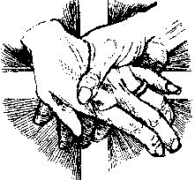
The Parish of St Gerard & St Anne
Baptism Registration Form
54-60 Knees Road Park Orchards VIC 3114
Phone: (03) 7064 3922
Email: parkorchards@cam.org.au
Full name of Child to be Baptised:
 | Date of Birth
Parent Information:
 | Child's Father | Full Name
 |  | Religion
 | Child's Mother | Full Name
 |  | Religion
 | Home Address
 | Email
 | Mobile
Other Children in the Family:
 | Name(s) & Date of Birth
God Parent Information:
 | God Father | Full Name
 |  | Religion
 | God Mother | Full Name
 |  | Religion
Please note: At least one Parent and one God Parent must be Catholic.
Important Dates - Attendance Required – Office to Complete
Preparation Meeting:
Welcome Mass:
Baptism Day:

